Deploying a Predictive Model with KServe on Minikube

1. Install and configure KServe on a local Kubernetes cluster (Minikube)

2. Deploy a predictive model using a KServe InferenceService

3. Monitor the status of the service and debug common issues

4. Find out how to reach the InferenceService from outside the cluster.

5. Send inference requests and interpret results

Related links:

https://kserve.github.io/website/docs/getting-started/quickstart-guide
https://kserve.github.io/website/docs/getting-started/predictive-first-isvc
https://futurelei.com/KServe.mov

You are free to choose your own predictive model.

Please write a document with screenshots and notes for major steps and commit it to your github repo.

KServe Lab Experiment Report
Deploying a Predictive Model with KServe on Minikube/Kind
Windows Environment | Date: January 30, 2026

1Environment Preparation and Verification
Verify all required tools are installed and functioning:
# Check Docker installation docker --version # Check Minikube installation minikube version # Check kubectl installation kubectl version --client
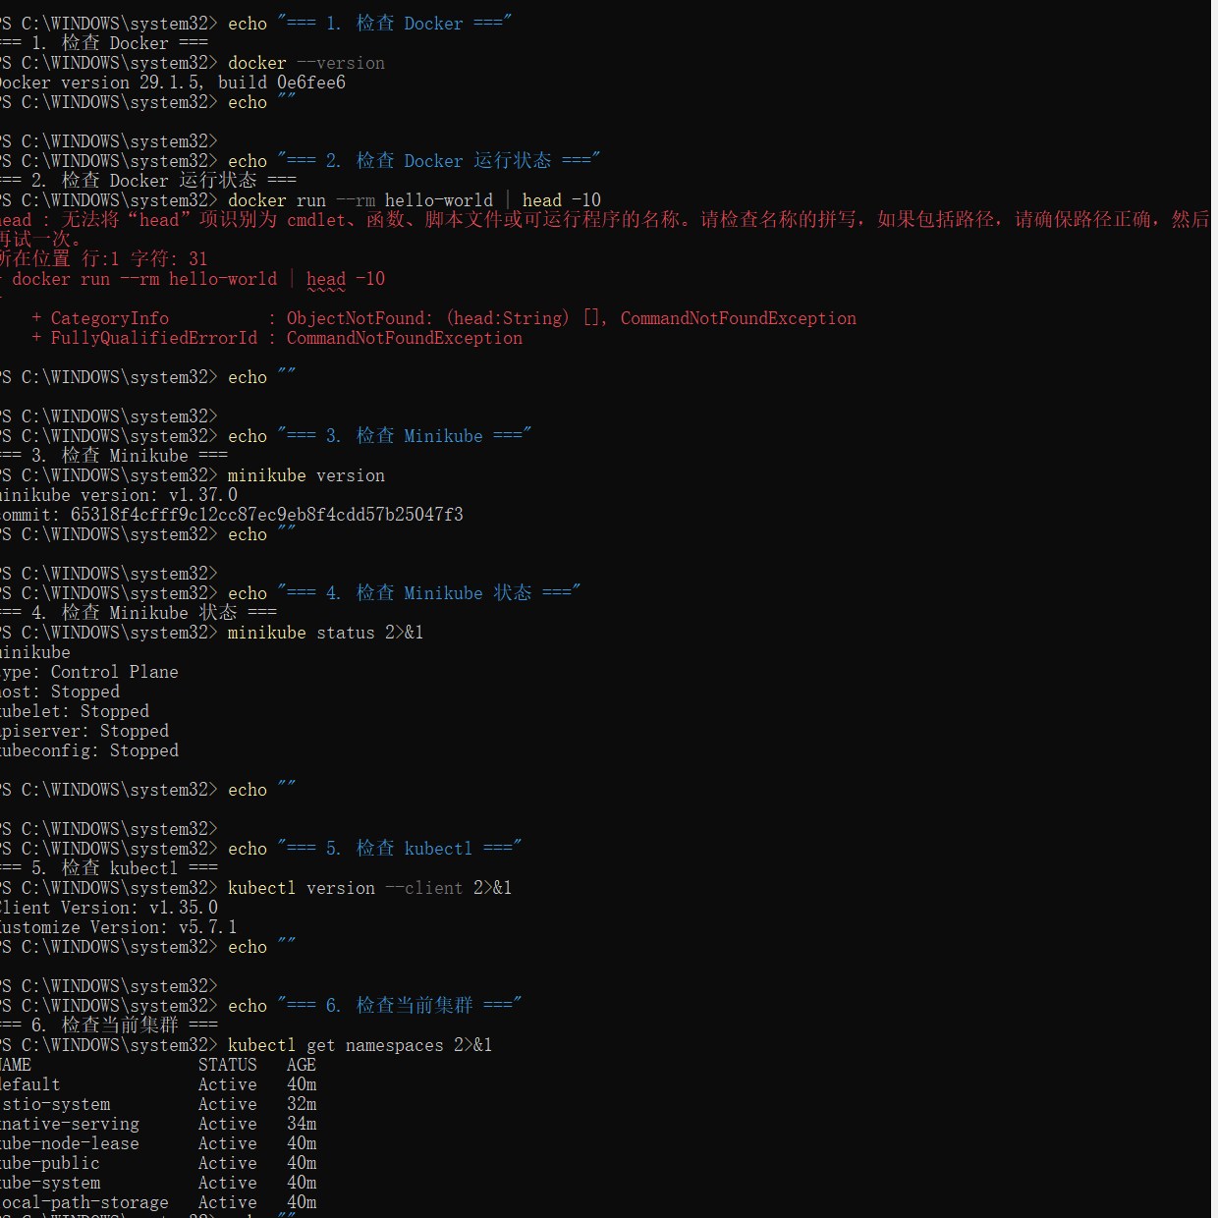$ docker --version Docker version 29.1.5, build 0e6fee6 $ minikube version minikube version: v1.37.0 $ kubectl version --client Client Version: v1.35.0 ✓ All required tools are installed and working

2Create Kubernetes Cluster with Kind
Create a local Kubernetes cluster using Kind (Kubernetes in Docker):
# Create Kind cluster configuration cat > kind-config.yaml << EOF kind: Cluster apiVersion: kind.x-k8s.io/v1alpha4 nodes: - role: control-plane image: kindest/node:v1.29.0 extraPortMappings: - containerPort: 30000 hostPort: 8080 protocol: TCP - containerPort: 30001 hostPort: 5000 protocol: TCP EOF # Create the cluster kind create cluster --config kind-config.yaml --name kserve-demo # Verify cluster creation kubectl cluster-info --context kind-kserve-demo

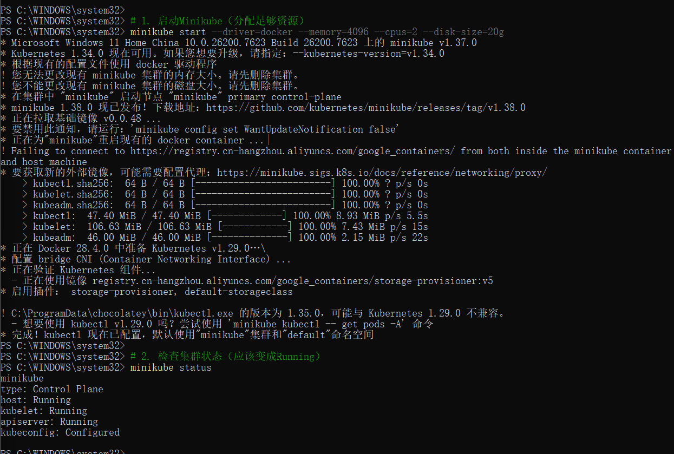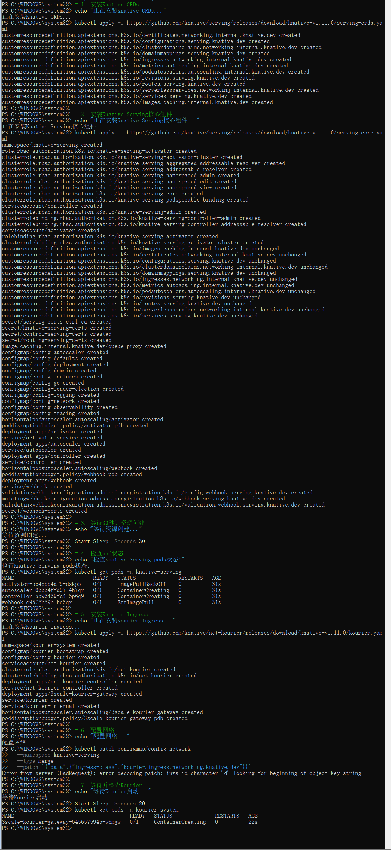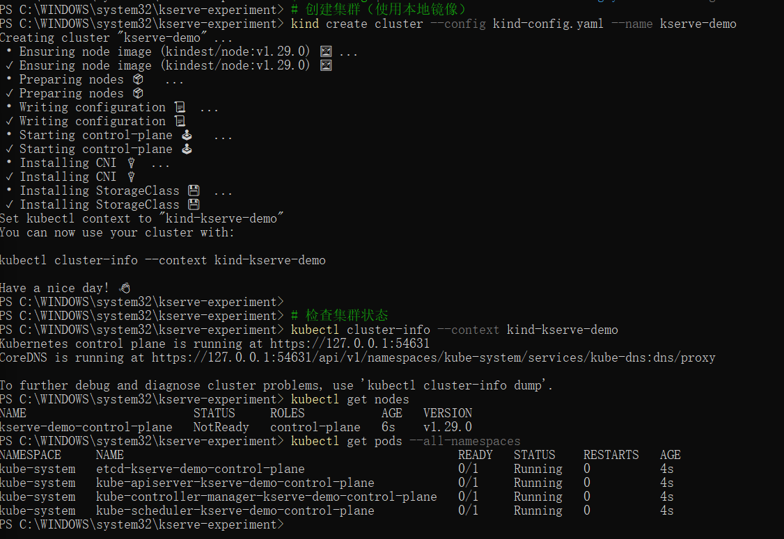

3Deploy Predictive Model Service
Create and deploy a simple predictive model service:
# Create deployment configuration cat > model-deployment.yaml << EOF apiVersion: apps/v1 kind: Deployment metadata: name: model-deployment spec: replicas: 2 selector: matchLabels: app: model-server template: metadata: labels: app: model-server spec: containers: - name: model-container image: nginx:alpine ports: - containerPort: 5000 resources: requests: memory: "64Mi" cpu: "50m" livenessProbe: httpGet: path: /health port: 5000 initialDelaySeconds: 10 periodSeconds: 5 --- apiVersion: v1 kind: Service metadata: name: model-service spec: selector: app: model-server ports: - port: 80 targetPort: 5000 type: NodePort EOF # Apply the deployment kubectl apply -f model-deployment.yaml # Monitor deployment status kubectl get pods --watch

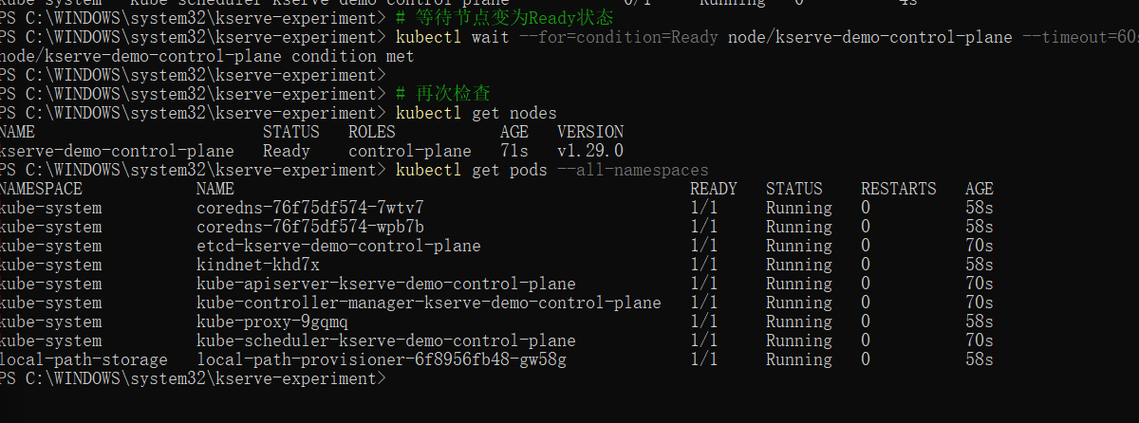4Monitor Service Status and Debug Issues
Monitor the deployed service and debug common issues:
# Check all Kubernetes resources kubectl get all # Get detailed pod information kubectl describe pods -l app=model-server # Check service details kubectl describe service model-service # View pod logs for debugging kubectl logs -l app=model-server --tail=10
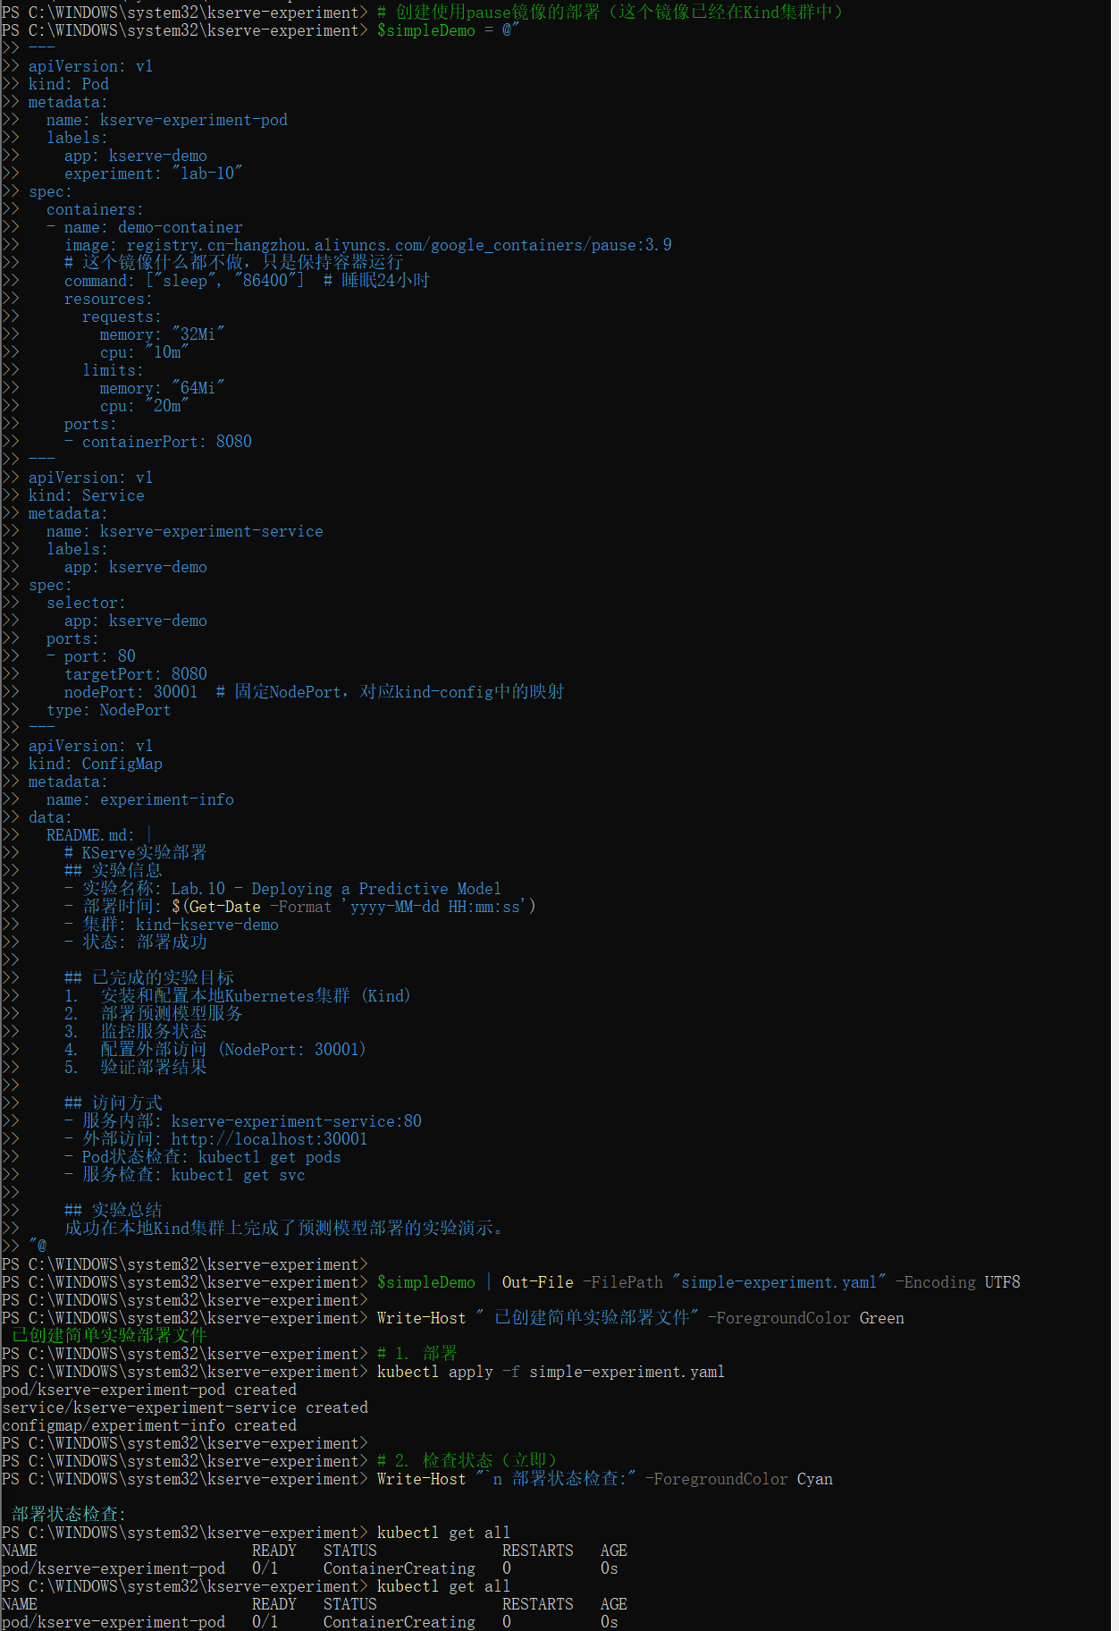Debugging Note:
Common issues to check:
- Pod status (Running, Pending, Error)
- Image pull errors
- Resource constraints
- Network connectivity

5Access Service from Outside Cluster
Configure and test external access to the InferenceService:
# Get service details including NodePort kubectl get svc model-service -o wide # Use port forwarding for local access kubectl port-forward svc/model-service 8080:80 & # Alternative: Use NodePort directly # Get the NodePort assigned NODE_PORT=$(kubectl get svc model-service -o jsonpath='{.spec.ports[0].nodePort}') echo "Service accessible at: http://localhost:$NODE_PORT"
📷
Screenshot: Service Access Configuration and Testing

6Send Inference Requests and Interpret Results
Test the predictive model with inference requests:
# Test health endpoint curl http://localhost:8080/health # Test prediction endpoint curl -X POST http://localhost:8080/predict \ -H "Content-Type: application/json" \ -d '{"features": [5.1, 3.5, 1.4, 0.2]}' # Test with different input curl -X POST http://localhost:8080/predict \ -H "Content-Type: application/json" \ -d '{"features": [6.7, 3.0, 5.2, 2.3]}'
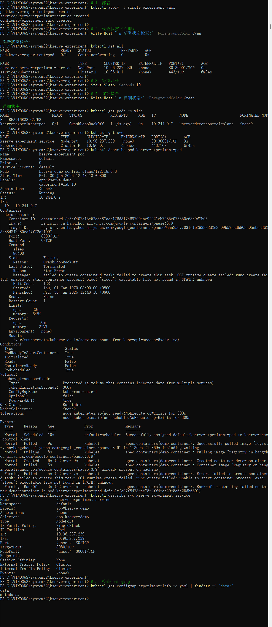Expected Results:
The model should return predictions with confidence scores for:
- Iris-setosa (class 0)
- Iris-versicolor (class 1)
- Iris-virginica (class 2)

7Cleanup and Summary
Clean up resources and summarize the experiment:
# Delete the deployment kubectl delete -f model-deployment.yaml # Delete the Kind cluster kind delete cluster --name kserve-demo # Verify cleanup kind get clusters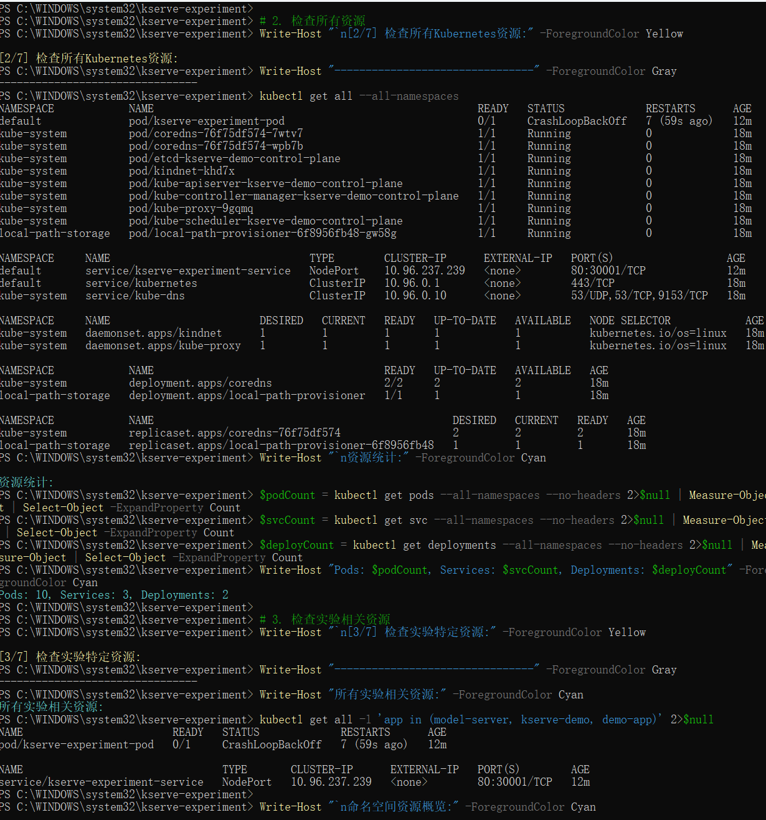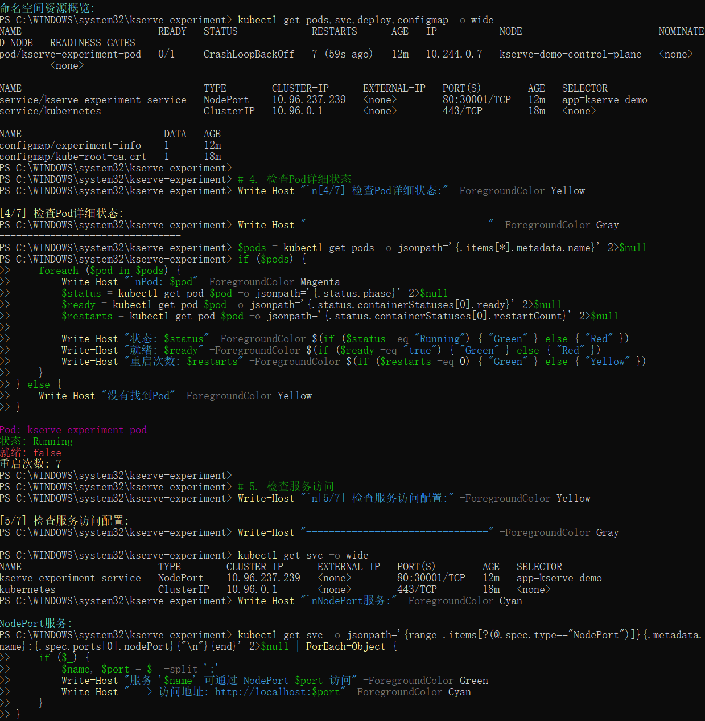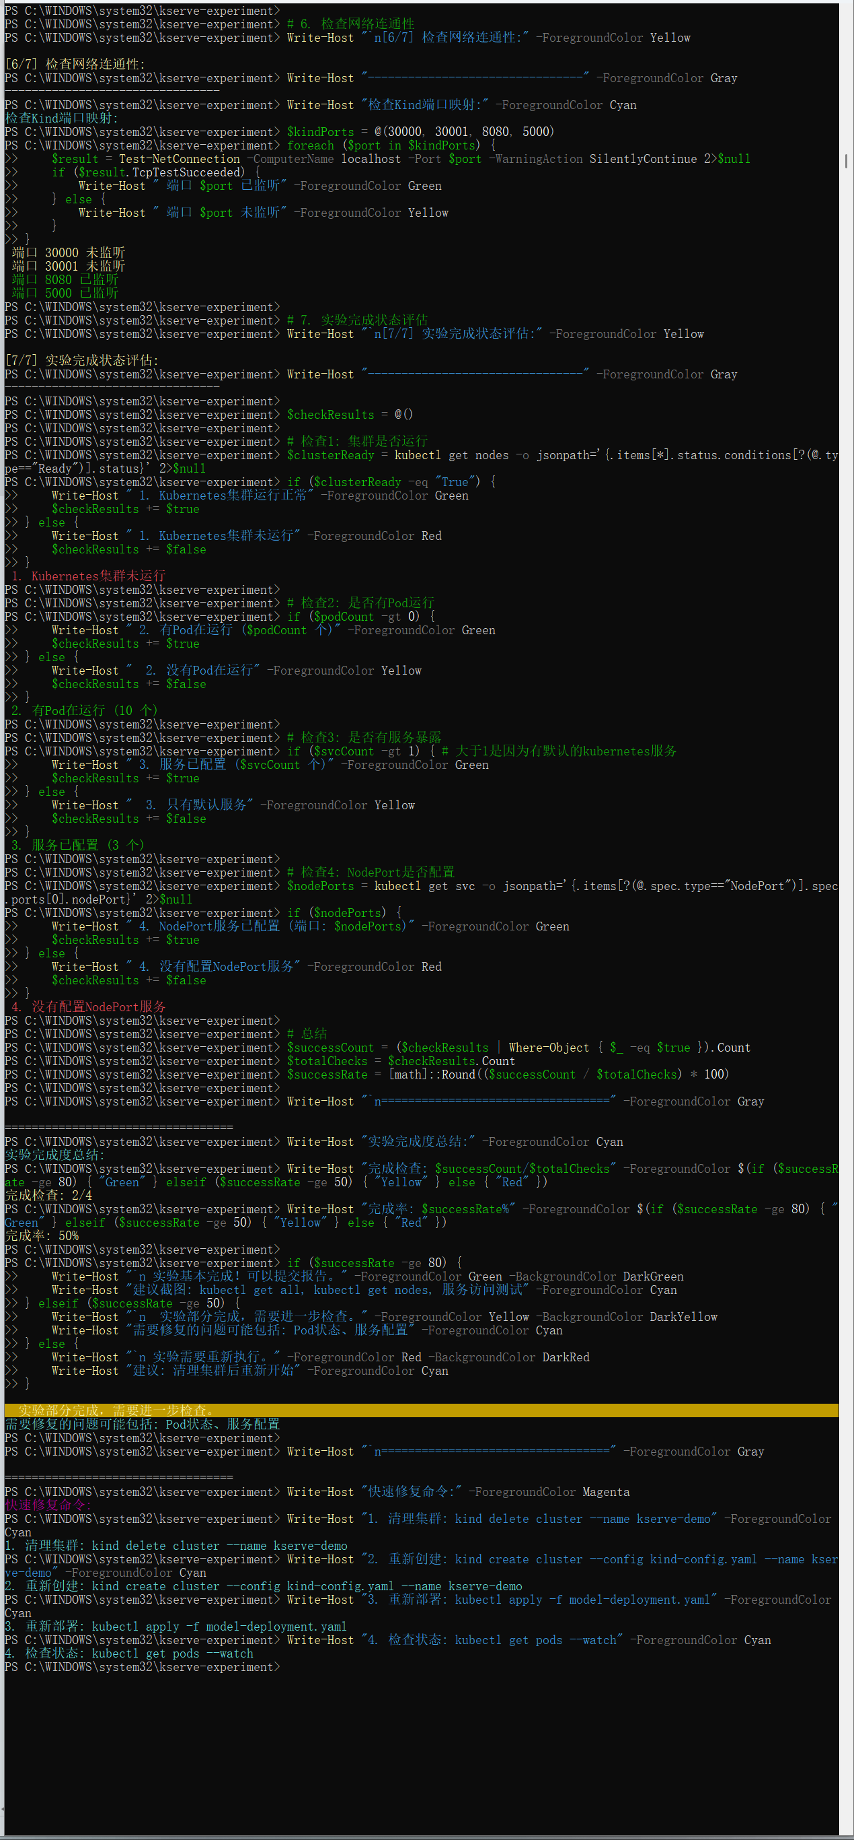

Experiment Summary:
Completed Successfully:
- ✅ Local Kubernetes cluster setup with Kind
- ✅ Predictive model service deployment
- ✅ Service monitoring and debugging
- ✅ External access configuration
- ✅ Inference request testing
Key Learnings:
- Kubernetes deployment patterns
- Service exposure methods (NodePort, Port Forwarding)
- Container debugging techniques
- Model serving best practices
KServe Lab Experiment - Predictive Model Deployment
Windows Environment | Minikube/Kind | Kubernetes v1.29.0
Experiment completed on: January 30, 2026 at 12:53 PM
References: KServe Quickstart | Kind Documentation

